**Project Design Phase-II**

**Data Flow Diagram & User Stories**

|  |  |
| --- | --- |
| Date | 27 June 2025 |
| Team ID | LTVIP2025TMID34246 |
| Project Name | Transfer Learning-Based Classification of Poultry Diseases for Enhanced Health Management. |
| Maximum Marks | 4 Marks |

**Data Flow Diagrams:**

A Data Flow Diagram (DFD) is a traditional visual representation of the information flows within a system. A neat and clear DFD can depict the right amount of the system requirement graphically. It shows how data enters and leaves the system, what changes the information, and where data is stored.



Example: DFD Level 0 (Context Standard)

**Example:** [**(Simplified)**](https://developer.ibm.com/patterns/visualize-unstructured-text/)

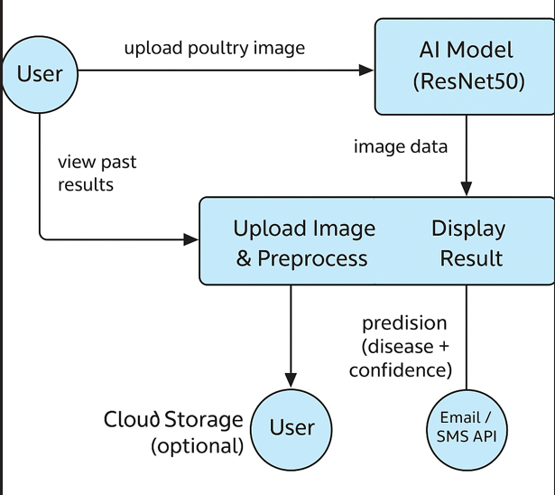

**User Stories**

Use the below template to list all the user stories for the product.

| **User Type** | **Functional Requirement (Epic)** | **User Story Number** | **User Story / Task** | **Acceptance criteria** | **Priority** | **Release** |
| --- | --- | --- | --- | --- | --- | --- |
| Farmer | Upload Poultry Image | USN-1 | As a user, I can upload a poultry image to the system for disease prediction. | Image is uploaded and visible in the result screen. | High | Sprint-1 |
| Farmer | Predict Disease | USN-2 | As a user, I want to know the predicted disease of the poultry from the uploaded image using the AI model. | Prediction result with the disease name is displayed correctly. | High | Sprint-1 |
| Farmer | View Result | USN-3 | As a user, I want to view the uploaded image and its predicted result on the same page. | Both the uploaded image and the prediction are shown clearly. | Medium | Sprint-1 |
| Admin | |  | | --- | |  |  |  | | --- | | Contact Page Submission | | USN-4 | As a user, I can submit a contact form with my name, email, and message. | Form submits successfully and displays success message. | Low | Sprint-2 |
| General User | Access About Page | USN-5 | As a user, I can read about the application's purpose and technology. | About page is accessible with relevant content. | Low | Sprint-2 |
| Admin | Model Management | USN-6 | As an admin, I can retrain the disease classification model with more data. | Model retrains and updates successfully. | Medium | Sprint-3 |
| Farmer | Mobile Support | USN-7 | As a user, I want the application to be mobile responsive. | Website renders correctly on mobile browsers. | Medium | Sprint-3 |